Problem Definition:
Small and medium-sized enterprises (SMEs) across Pakistan — from toy shops and clothing boutiques to grocery outlets and electronics retailers — continue to rely on manual, error-prone inventory practices. Stock levels are tracked through physical registers or simple spreadsheets; sales data is neither consolidated nor analyzed; and employee performance is evaluated entirely on subjective grounds. This absence of a unified digital system produces a compounding chain of operational failures: capital is locked in overstock, customer trust erodes during stockouts, demand remains un-forecasted, and local storefronts lack any mechanism to reach buyers beyond their immediate vicinity.
Introduction to SMAS:
SMAS (Stock Monitoring & Analytic System) is a web-based ERP platform for Pakistani retail businesses — covering inventory, order management, employee operations, financial accounting, and real-time analytics in one integrated system.
Key Features:
Following are the key features that we have implemented in our system:
- Real Time Inventory Control — Add, Edit, Track stock levels, Set reorder alerts.
- Order Processing — Full order lifecycle from pending to delivered with real-time tracking.
- Employee Performance Tracking — Set roles, manage salaries, commissions, and approval workflows.
- Customer Portal — Online shopping, cart, Wishlist, order tracking, complaint filing.
- Financial Accounting — Tax calculations, discount management, commission tracking, salary summaries.
- Real-Time Dashboard — Live charts showing revenue trends, sales by city, product performance.
- Notification System — Real-time alerts for orders, complaints, and stock alerts.
- Role-Based Access Control — Admin, Salesman, and Buyer each see only what they need.

Role | How SMAS Helps Them
Admin | Full control — products, employees, orders, reports, settings, complaints. Live dashboard with revenue trends.
Salesman | Track personal sales, view commissions earned, process walk-in customer orders.
Buyer / Customer | Browse products, manage cart and wishlist, place online orders, track deliveries, file complaints.

System Architecture & Technology Stack
SMAS follows a strict three-layer architecture as explained in the table below:
Layer | Technology | Role
Layer 1 — Presentation | Html, CSS & JavaScript | Buttons, screens, tables, and charts in the browser
Layer 2 — Business Logic | ASP.NET Core 8 + C# | Calculates tax, applies discounts, checks permissions
Layer 3 — Data | PostgreSQL | 23 tables storing all data permanently

Backend Architecture

Based on our backend review, here's a quick explanation.
- Controllers
Receive HTTP requests and forward them to services. Contain no business logic. Examples: AuthController, OrdersController, ProductsController.
- Services
Handle core business logic like validation, calculations, and processing. Examples: OrderService, AuthService, ReportService.
- Repositories
Manage database operations (CRUD) using Entity Framework Core and connect services to the database. Examples: ProductRepository, OrderRepository.
- Models
Define database entities as C# classes and represent table structures. Examples: Product, Order, Employee, Customer.
- DTOs (Data Transfer Objects)
Carry only required data between backend and frontend to improve security and efficiency. Examples: LoginDto, CreateOrderDto, ProductResponseDto.
- Middleware
Handle cross-cutting tasks like authentication, logging, and error handling across the application. Examples: JwtMiddleware, GlobalExceptionMiddleware.
A block diagram below explains this architecture more briefly:
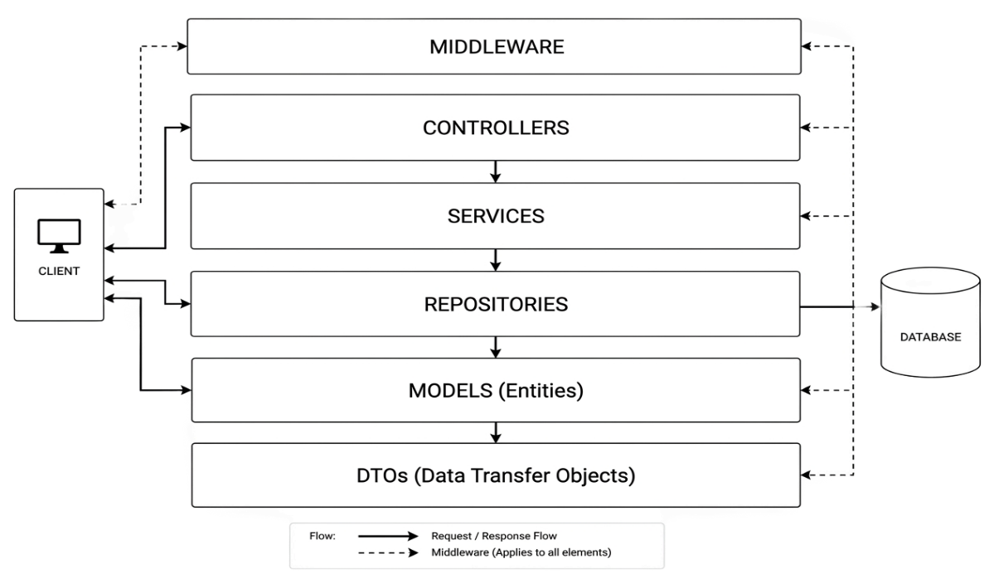

OOP Concepts Implementation
All the core concepts related to Object Oriented Programing as discussed as follows:
Classes
Multiple Classes are made based upon the functionality and requirement of them i.e. Entity, Products, Orders, Employee etc.
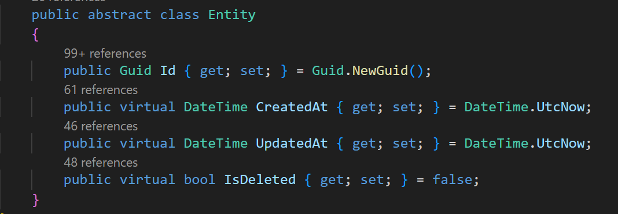
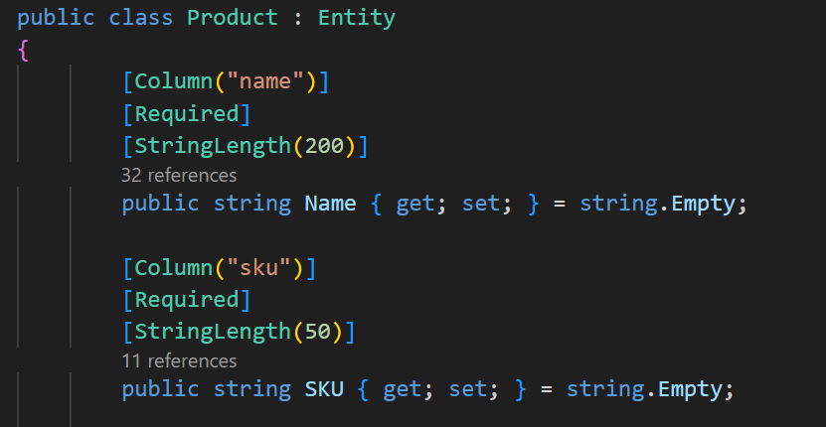

Inheritance
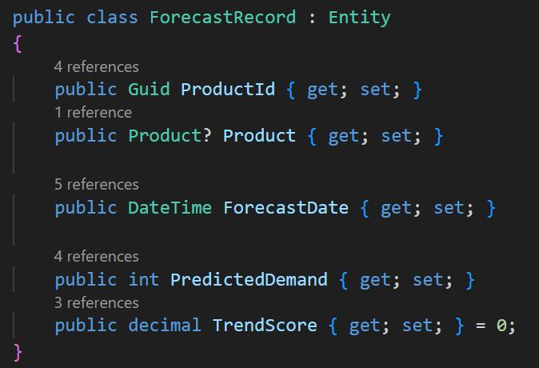
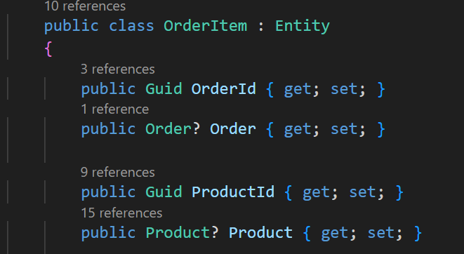
All 17 models have a common inheritance from the base class of Entity. Classes like Supplier, Sale_Record, Order_Items, all have their own as well as entity class attributes inherited.

Encapsulation
All the internal details are hidden and exposed only through controlled public properties such as:
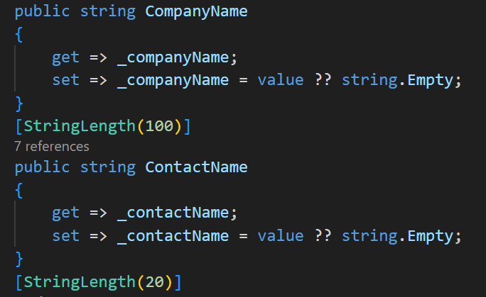
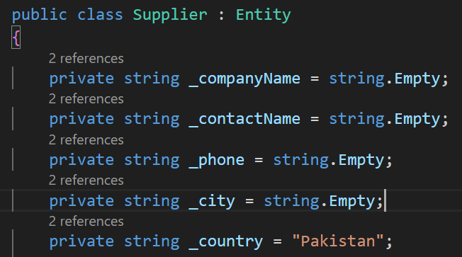

Use of Private access modifier and get/set functions ensures encapsulation.
Polymorphism
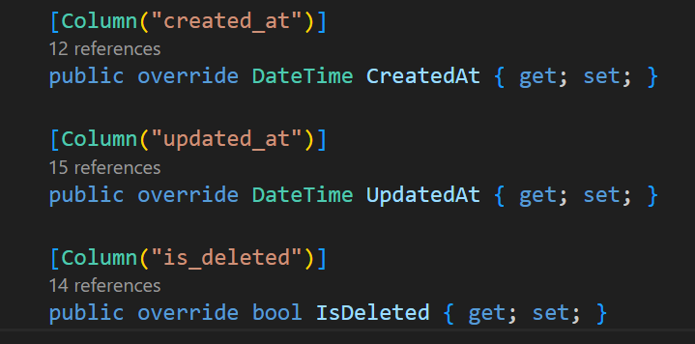
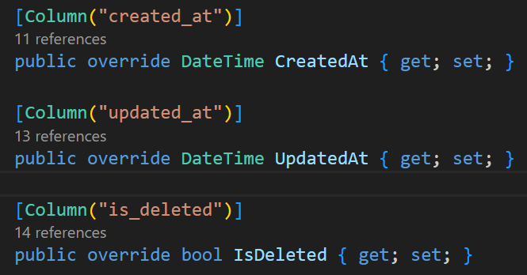
Implementation of this principal can be in various portions of our models, some snippets are:

Products Model
Order Model
Abstraction
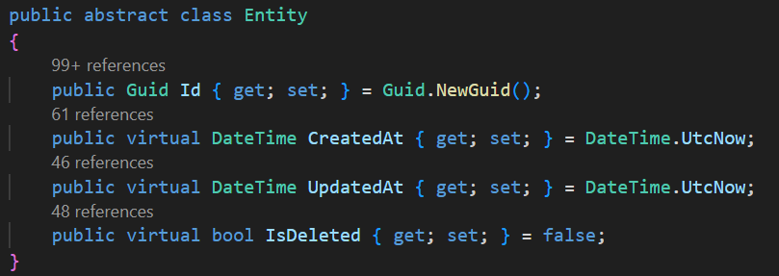
Entity class is an abstracted class whose attributes are inherited all over the other models.

Class Diagram:
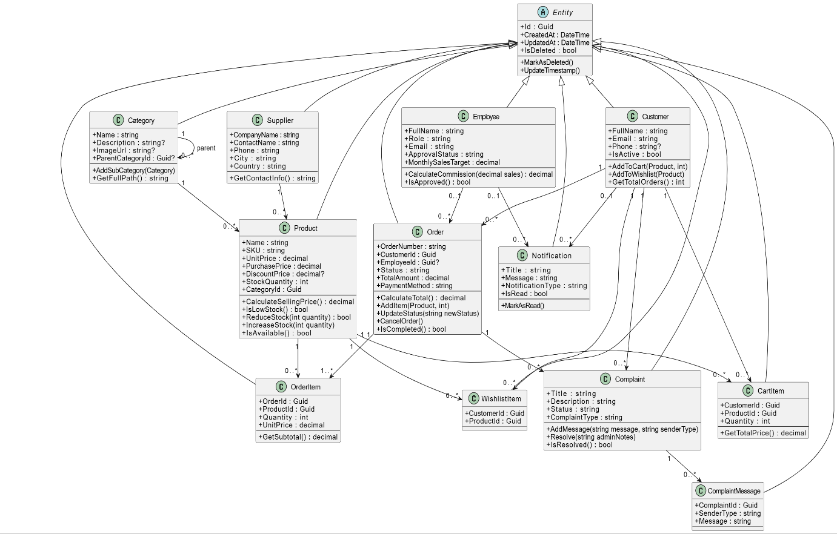

DATABASE DESGIN
The SMAS database runs on PostgreSQL with 23 tables in Third Normal Form (3NF). Every table has a UUID primary key, timestamp columns, and a soft-delete flag. The Code-First approach means C# classes are the source of truth — EF Core generates all SQL from model changes.

Core Commerce Module

The Core Commerce Module handles the system’s primary business flow, including product management, category organization, order processing, and order item mapping. It forms the backbone of all buying and selling operations within the platform.
Table | Attributes
Products | Name, SKU, UnitPrice, StockQuantity, ReorderLevel, Status
Categories | Name, ParentCategoryId
Suppliers | CompanyName, ContactName, Phone, City
Orders | OrderNumber, Status, TotalAmount, TaxAmount, CourierRef
Order Items | OrderId (FK), ProductId (FK), Quantity, UnitPrice

User Management Module
The User Management Module controls all system users, including customers and employees, along with authentication and access control. It manages user profiles, roles, approval status, and secure session handling through refresh tokens.
Table | Attributes
Customers | FullName, Email, Phone, City, Province, Address
Employees | FullName, Email, Role, PasswordHash, ApprovalStatus
Refresh Tokens | Token (UNIQUE), UserId, UserType, ExpiryDate

Inventory & Supply Chain Module

The Inventory & Supply Chain Module manages product stock flow from suppliers to the system, ensuring accurate tracking of inventory levels. It handles stock movements, low-stock alerts, and product sourcing to maintain operational continuity.
Table | Attributes
Supplier | CompanyName, Contact_Name, Phone, City
Inventory Transactions | ProductId (FK), QuantityChange, TransactionType
Stock Alerts | ProductId (FK), CurrentStock, ReorderLevel, IsResolved
Product Images | ProductId (FK), ImageUrl, IsPrimary

Pricing, Sales & Forecasting Module

The Pricing, Sales & Forecasting Module manages product pricing strategies, employee commissions, and sales history tracking. It also supports demand prediction to help optimize inventory planning and revenue forecasting.
Table | Attributes
Discounts | ProductId (FK), DiscountPercentage, StartDate, EndDate
Commissions | EmployeeId (FK), ProductId (FK), CommissionPercentage
Sale Records | ProductId (FK), EmployeeId (FK), SaleDate, Revenue
Forecast Records | ProductId (FK), ForecastDate, PredictedDemand

Customer Interaction Module

The Customer Interaction Module handles all customer-facing activities such as complaints, cart management, wishlist, and notifications. It ensures smooth communication between customers and the system for support, feedback, and engagement.
Table | Attributes
Complaints | OrderId (FK), ComplaintType, Status, EvidenceImageUrl
Complaint Messages | ComplaintId (FK), SenderType, Message
Cart Items | CustomerId (FK), ProductId (FK), Quantity
Wish list Items | CustomerId (FK), ProductId (FK)
Notifications | EmployeeId (FK), Title, NotificationType, IsRead

System & Logging Module
The System & Logging Module maintains system-wide configuration and tracks all critical actions performed within the application. It ensures auditability, traceability, and centralized control through logs and configurable settings.

Table | Attributes
AuditLogs | EntityName, Action, PerformedBy, OldValues, NewValues
SystemSettings | Key (UNIQUE), Value, Description
Entity (base) | Id (UUID), CreatedAt, UpdatedAt, IsDeleted

Entity Relationships (ERD)
The database consists of core business entities and supporting modules that are interconnected through well-defined relationships. All entities inherit common auditing fields from the base Entity class (Id, CreatedAt, UpdatedAt, IsDeleted).

Product Entities

Table A | Cardinality | Table B | Meaning
Categories | 1 : N | Products | One category holds many products
Categories | 1 : N | Categories (self) | Parent category has subcategories
Suppliers | 1 : N | Products | Supplier deleted — products stay, lose reference
Products | 1 : N | Order Items | One product appears in many order items
Products | 1 : N | Discounts | One product has many discount entries
Products | 1 : N | Product Images | One product has many photos

Order & Customer Entities

Table A | Cardinality | Table B | Meaning
Customers | 1 : N | Orders | One customer places many orders
Employees | 1 : N | Orders | Employee deleted but orders preserved
Orders | 1 : N | Order Items | One order contains many items
Orders | 1 : N | Complaints | One order can have many complaints
Complaints | 1 : N | ComplaintMessages | One complaint has a chat thread
Customers | 1 : N | Cart Items | Customer deleted and cart cleared

Employee & Finance Entities

Table A | Cardinality | Table B | Meaning
Employees | 1 : N | Sale Records | Employee deleted — sales data preserved
Employees | 1 : N | Commissions | Employee deleted — commission rates deleted
Products | 1 : N | Commissions | Product deleted — commission rates deleted
Employees | 1 : N | Notifications | Employee deleted — notifications removed

For better visualization and understanding few screenshots have been added:

Product Table:
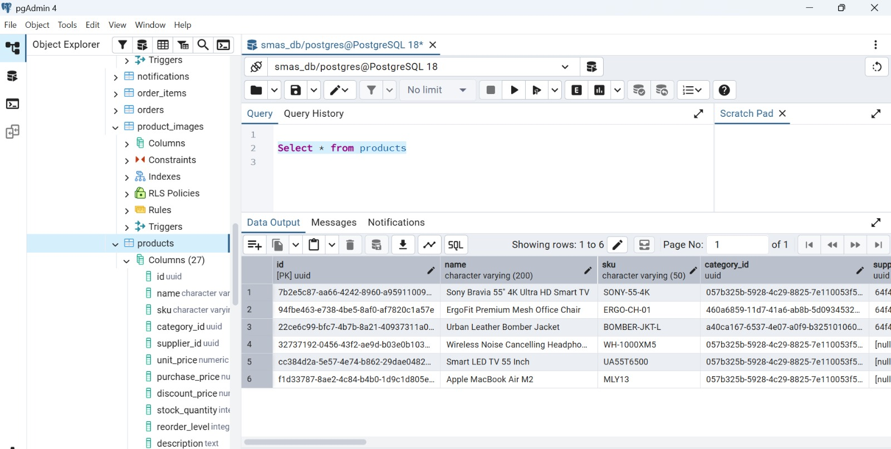

Order Items Table:

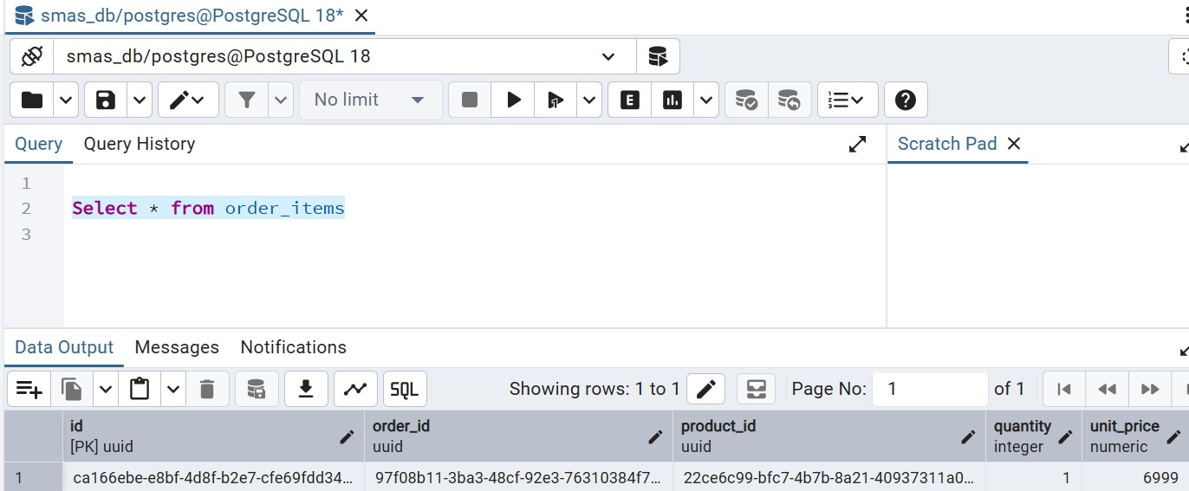
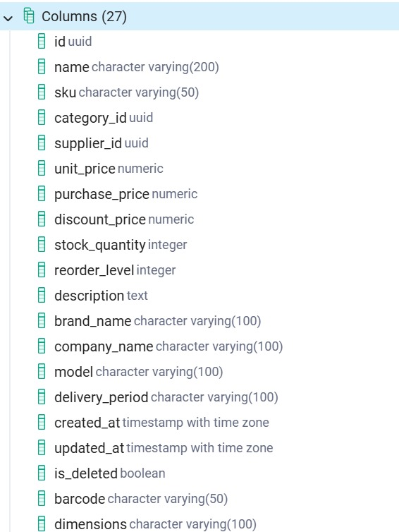
Product Table Attributes:

Entity-Relationship Diagram:

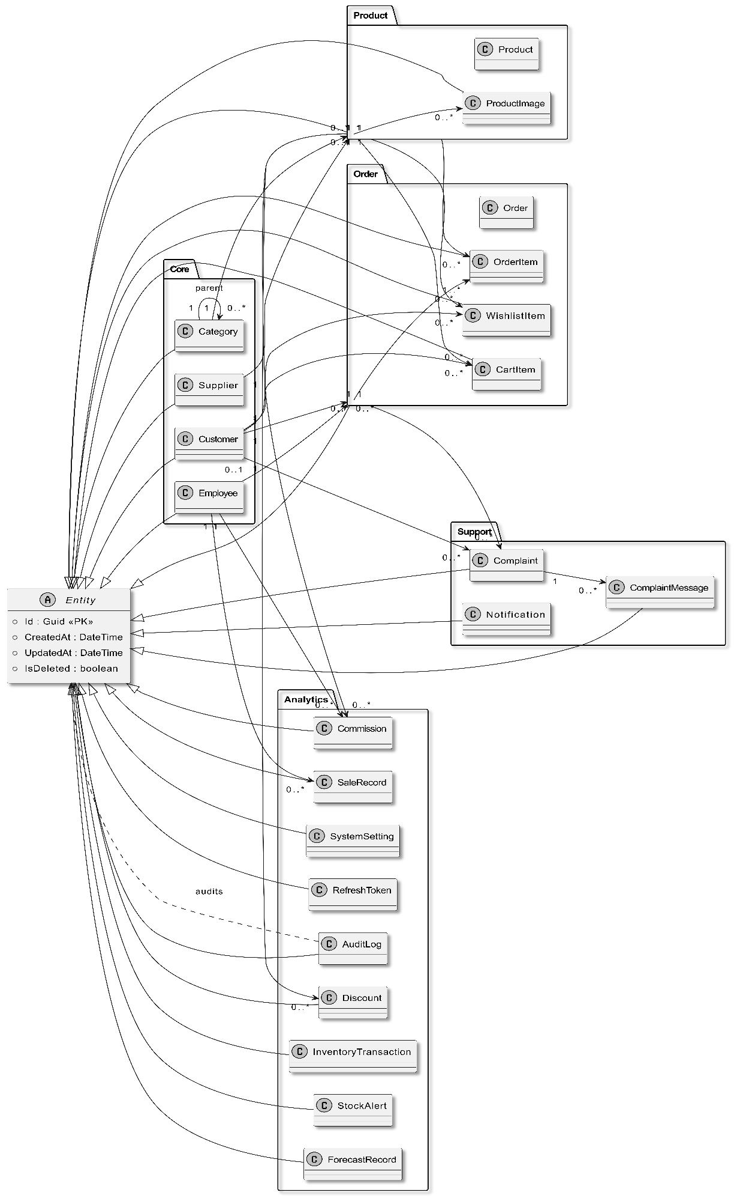

Front-End Architecture:
The frontend of SMAS is a modern and responsive web application built to deliver a smooth, intuitive, and user-friendly experience for customers, employees, and administrators alike.
It seamlessly communicates with the SMAS.API backend through clean RESTful APIs and follows well-organized architecture principles. This ensures the application is not only easy to use but also scalable, maintainable, and performant as the system grows.
Objectives:
- Admin & Employee Dashboards
- Product Browsing & Search
- Shopping Cart & Checkout
- Sales Reports & Charts
- Employee Performance View
- Region-wise Sales Analysis

- Real-time Inventory Monitoring
- Low Stock Alerts
- Online Shopping Storefront
Websites ScreenShots:
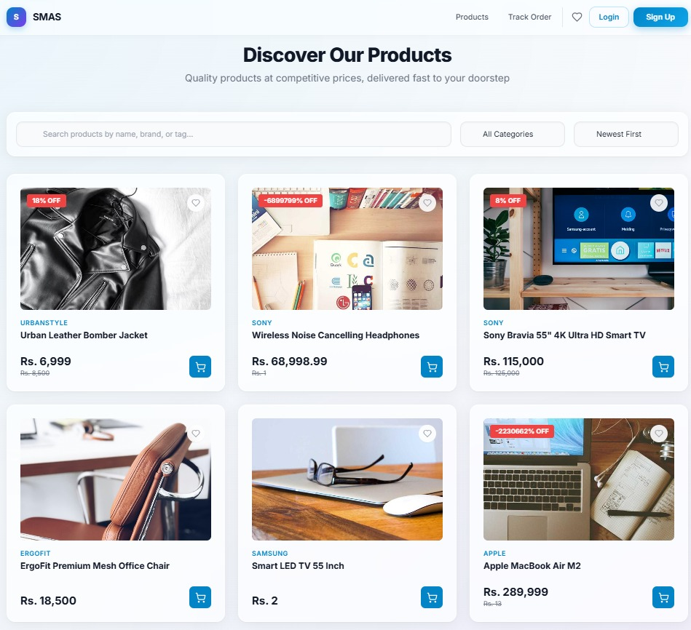
Dashboard:

Products:
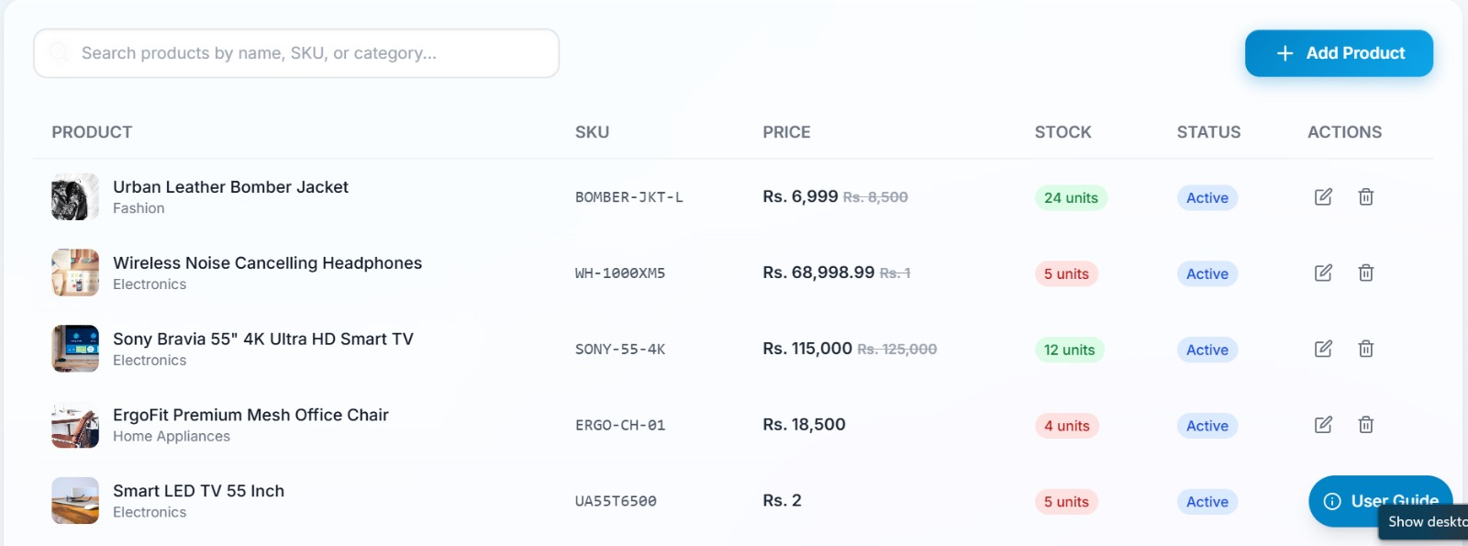
Order Notification:
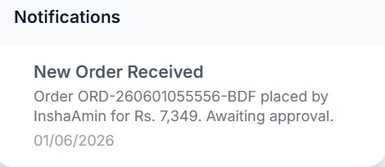
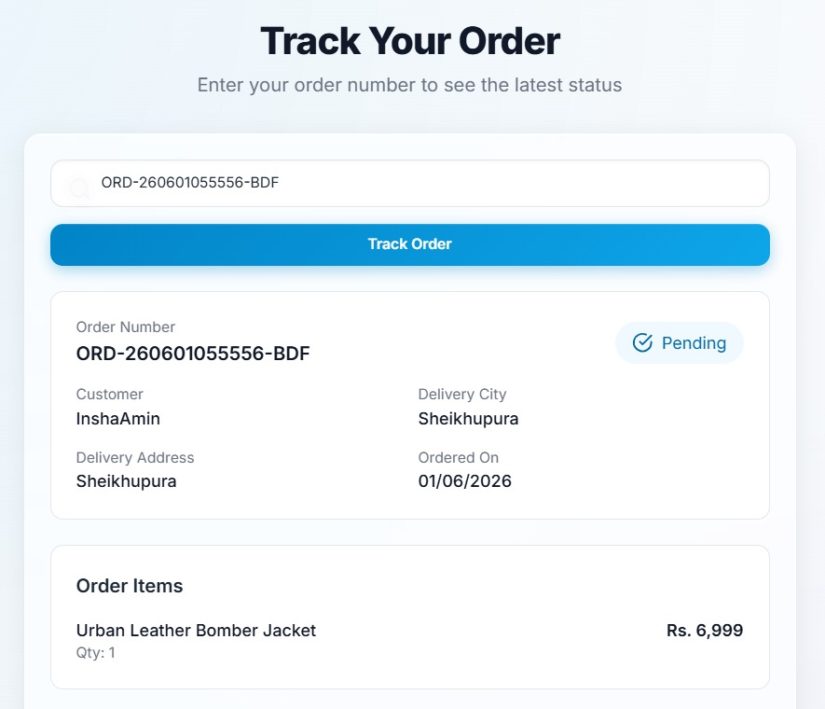
Track your Order:

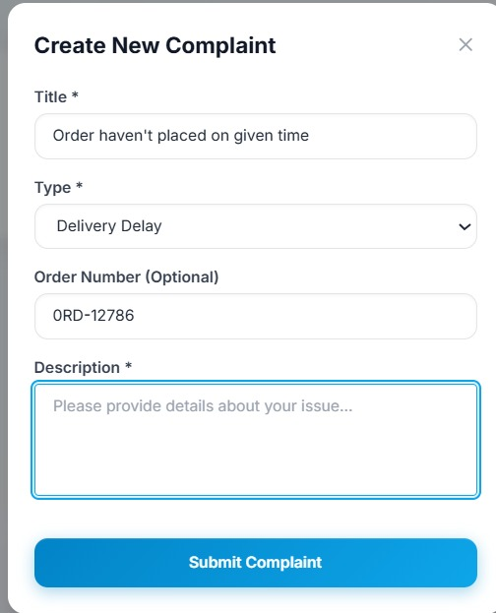
Complaint:

Admin Complaint Panel:
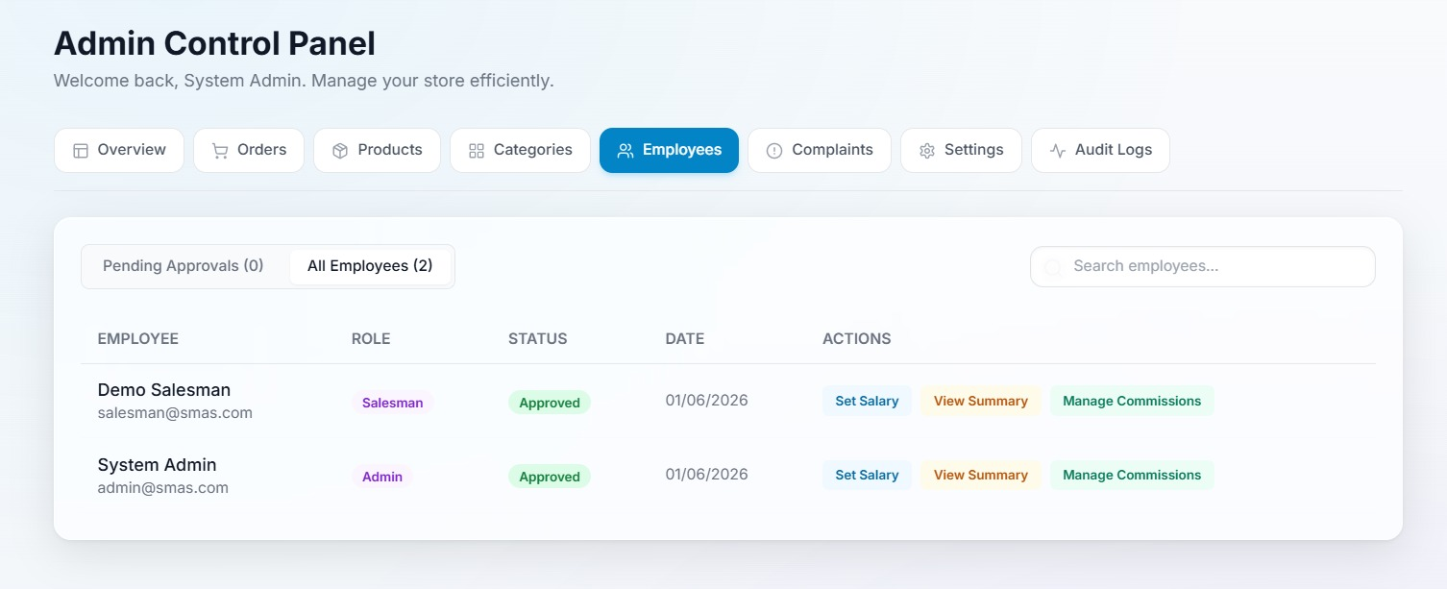

Frontend – Backend Integration:
The back-end, built with ASP.NET Core Web API, handles all business logic, data processing, and database operations. The front-end communicates with the back-end through RESTful API endpoints using fetch requests. All data is exchanged in JSON format, ensuring fast and efficient communication.
Deployment:
For deploying the project, we used github to post our repository, render to build our system using docker file and netlify for frontend deployment. We linked our frontend with backend using the link render generated.
Render Deployment
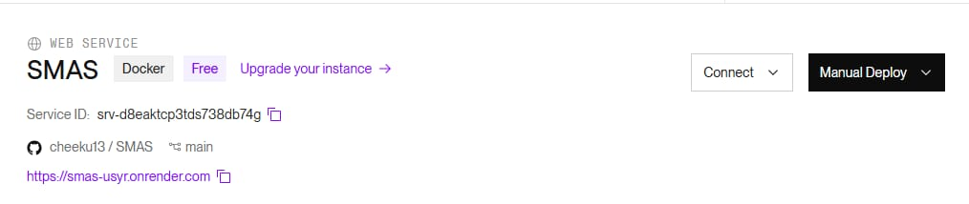
GitHub
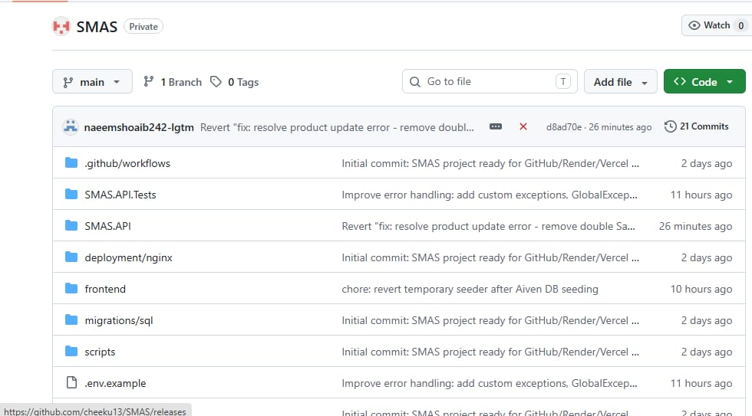

Certifications:
Muneeb Bin Anjum (2025-DS-74):
I used LINQ in this project to query and filter data collections directly in C# without writing lengthy loop logic. It allowed me to replace multiple foreach loops with clean, single-line expressions making my code shorter, more readable, and easier to maintain.


Ayyan Shahid (2025-DS-93):

I used Docker in this project to containerize the application so it runs consistently across different environments without any setup issues.

Insha Amin (2025-DS-60):
I used PostgreSQL in this project as the main database because it is reliable, open-source, and handles complex SQL queries efficiently. It supported all the data storage and retrieval needs of the application while offering strong performance and data integrity out of the box.
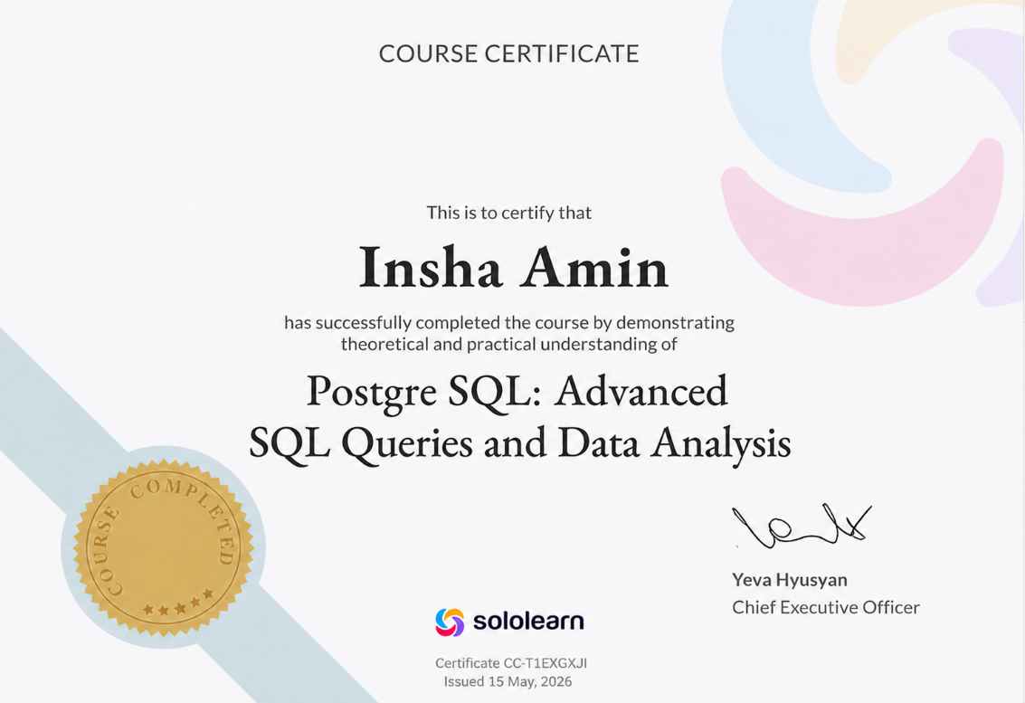

Umair Naeem (2025-DS-65):
I built the frontend using React because it allowed me to create a dynamic and responsive user interface efficiently using reusable components. For the backend, I used Node.js because it is fast, lightweight, and works seamlessly with React, making the overall development process smoother and more consistent across the full stack.


